**HERITAGE INSTITUTE OF TECHNOLOGY**

**KOLKATA**



DEPARTMENT OF

APPLIED ELECTRONICS AND INSTRUMENTATIONENGINEERING

### LABORATORY REPORT

MICROPROCESSORS AND MICROCONTROLLERS LABORATORY

PAPER CODE: AEIE3153

B. Tech 3rd Year 1st Semester

Name: Rahul Kumar Singh

College Roll No:1953005

University Roll No: 12619005033

Academic Year: 2021

**INDEX**

| **Assignment No** | **Date of Experiment** | **Date of Submission** | **Title** | **Page No** | **Signature** | **Remark** |
| --- | --- | --- | --- | --- | --- | --- |
| **1** |  | **13/11/21** | **Study of programs using basic instruction set (data transfer, load/store, arithmetic, logical) of 8085A microprocessor.** | **1** |  |  |
|  |  |  |  |  |  |  |
|  |  |  |  |  |  |  |
|  |  |  |  |  |  |  |
|  |  |  |  |  |  |  |
|  |  |  |  |  |  |  |
|  |  |  |  |  |  |  |
|  |  |  |  |  |  |  |
|  |  |  |  |  |  |  |
|  |  |  |  |  |  |  |
|  |  |  |  |  |  |  |
|  |  |  |  |  |  |  |
|  |  |  |  |  |  |  |
|  |  |  |  |  |  |  |
|  |  |  |  |  |  |  |
|  |  |  |  |  |  |  |
|  |  |  |  |  |  |  |
|  |  |  |  |  |  |  |

**Sample Program: Write a program to transfer (copy paste) a block of data (10 byte) starting from memory location 2050H to another memory location starting from 2060H.**

**Program:** Code starting address: 2000H

| **Label** | **Mnemonics** | **Comments** |
| --- | --- | --- |
|  | LXI H,2050H | Load starting address of source block |
|  | LXI D,2060H | Load starting address of destination block |
|  | MVI C,0AH | Initialize counter with number of data |
| L1: | MOV A,M | Move data from source block to accumulator |
|  | STAX D | Move data from accumulator to destination block |
|  | INX H | Increment source memory pointer by 1 |
|  | INX D | Increment destination memory pointer by 1 |
|  | DCR C | Decrement counter by 1 |
|  | JNZ L1 | Check and go to label L1 if Z=0 |
|  | HLT | Halt |
|  |  |  |
|  |  |  |
|  |  |  |
|  |  |  |
|  |  |  |
|  |  |  |
|  |  |  |
|  |  |  |
|  |  |  |
|  |  |  |
|  |  |  |
|  |  |  |
|  |  |  |

**Input Data:**

Data starting address: 2050H

DB 77H,77H,77H,44H,55H,66H,77H,88H,99H,77H

**Result (**Screenshot of Simulator**):**

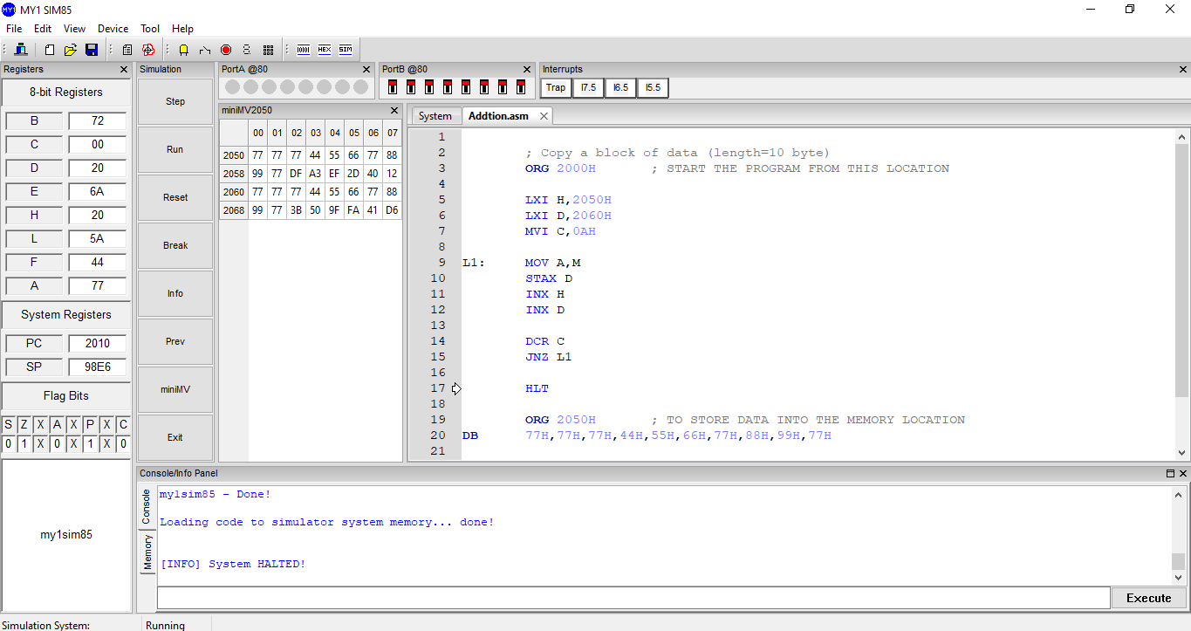

**Assignment No-2.A: ……………………….**

**Program:** Code starting address:

| **Label** | **Mnemonics** | **Comments** |
| --- | --- | --- |
|  | MVI A,33H | Initialize counter with number of data |
|  | LXI H,5017H | **Load starting address of source block** |
|  | MOV C,A | Move data from source block to accumulator |
|  | XCHG | Exchange 16 bit data of DE and HL |
|  | HLT | Halt |
|  |  |  |
|  |  |  |
|  |  |  |
|  |  |  |
|  |  |  |
|  |  |  |
|  |  |  |
|  |  |  |
|  |  |  |
|  |  |  |
|  |  |  |
|  |  |  |
|  |  |  |
|  |  |  |
|  |  |  |
|  |  |  |
|  |  |  |
|  |  |  |

**Input Data:**

Data starting address:

2000H DB 33H,5017H

**Result (**Screenshot of Simulator**):**

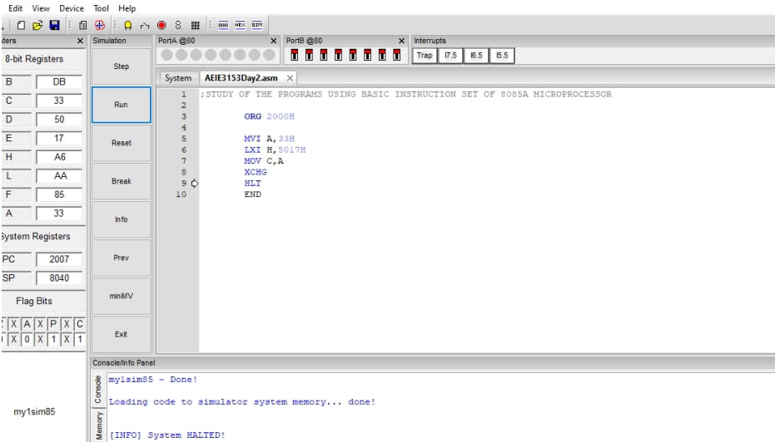

**Assignment No-2.B:…………………….**

**Program:** Code starting address: 2000H

| **Label** | **Mnemonics** | **Comments** |
| --- | --- | --- |
|  | LDA 3000H | TRANSFER/LOAD 8 BIT DATA FROM MEMORY LOCATION |
|  | MOV B,A | **COPY THE DATA ITEMS** |
|  | STA 3001H | TRANSFER FROM A REGISTER TO MEMORY LOCATION |
|  | HLT | HALT |
|  | ORG 3000H | INDICATE THE BEGINNING IF THE ADDRESS |
| DB | 33H |  |
|  | END |  |
|  |  |  |
|  |  |  |
|  |  |  |
|  |  |  |
|  |  |  |
|  |  |  |
|  |  |  |
|  |  |  |
|  |  |  |
|  |  |  |
|  |  |  |
|  |  |  |
|  |  |  |
|  |  |  |
|  |  |  |
|  |  |  |

**Input Data:**

Data starting address: : 3000H

DB 33H

**Result (**Screenshot of Simulator**):**

